**P&ID PRINT READING**

Name:_________Xinyu Liu_______________

1. Review the diagram shown in Figure 1.
   1. Identify the following components by letter or number. There may be multiple answers for each item.

|  |  |
| --- | --- |
| ____A,B___ | Centrifugal pump |
| ___C,D____ | Heat exchanger |
| ___E____ | Tank |
| ____30,31___ | Venturi Sensor |
| ___1____ | Rupture disc |
| ____8,17___ | Relief valve |
| __2,3,7,16___ | Motor-operated valve |
| ___32____ | Pneumatic (Air) operated valve |
| ___12,24____ | Needle valve |
| ___26___ | Conductivity cell |
| ____32___ | Pneumatic (Air) line |
| ___28____ | Current-to-pneumatic converter |
| __5,14_____ | Check valve |
| 18,19, ____ | A locked-closed valve |
| 18,19 ____ | A closed valve |
| ___4____ | A locked-open valve |
| ___11,23____ | A solenoid valve |

* 1. What are the controlling parameters for Valves 10 and 21?

Supply Air Pressure

**As there are air lines connecting to the valves 10 and 21**

* 1. Which valves would need to change position (open/closed) in order for Pump **B to supply flow to only points F and G**, while maintain the proper operating parameters of temperature and pressure?

**Open 18, 19 and close 21**

* 1. Which valves will fail open? Fail closed? Fail as is?

**Fail open**

**2, 3**

**Fail close**

**10, 21**

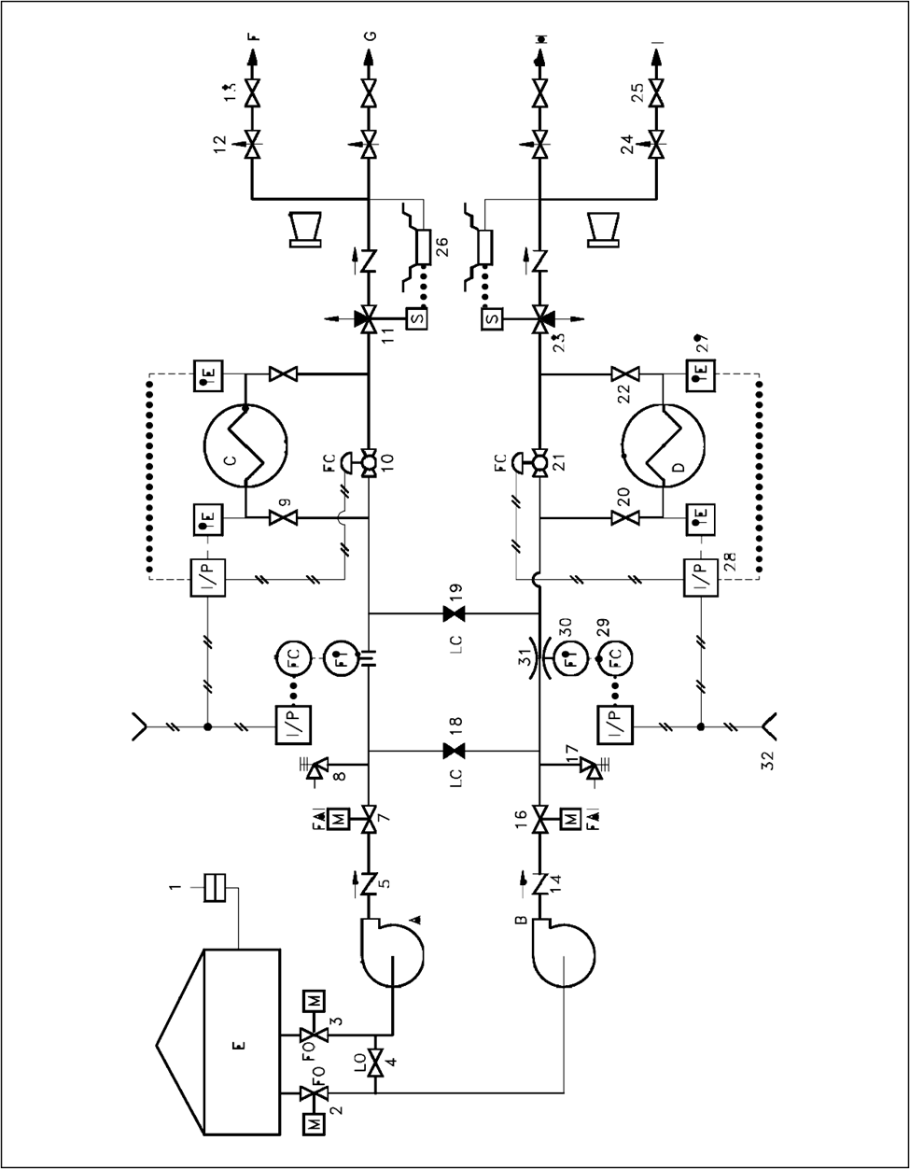

Figure 1

1. Draw a Block Flow Diagram (BFD) or Process Flow Diagram (PFD) of the process involved in making your favorite food using the principles of Engineering Symbology. Your drawing and labeling should be very neat if hand drawn, or use electronic drafting techniques.

**Block Flow Diagram For Making Cheese from Raw Milk**

图示

3. Identify all of the numbered components for the process P&ID in Figure 3.

|  |  |  |  |
| --- | --- | --- | --- |
|  | Vertical Vessel |  | Butterfly valve |
|  | Motor-operated Valve |  | Heat Exchanger |
|  | Gas blower |  | Control Valve |
|  | Orifice |  | Diaphragm valve |
|  | Control Valve |  | Temperature element |
|  | Flow transmitter |  | Heat Exchanger |
|  | Flow controller |  | Boiler |
|  | Current to pneumatic converter |  | Control valve |
|  | Furnace |  | Mixer |
|  | Temperature transmitter |  | Pressure transmitter |
|  | Temperature controller |  | Pressure controller |
|  | Pneumatic Control |  | Control Valve |
|  | Control Valve |  | Level transmitter |
|  | Column |  | Gas blower |
|  | Motor-Operated Valve |  | Gas blower |
|  | Gas blower |  | Check Valve |
|  | Globe Valve |  | Staggered Baffle Trays Column |
|  | Pneumatic Binary Signal Line |  | Control Valve |
|  | Level controller |  | Vacuum pump |
|  | Level transmitter |  | Hydrocracking |
|  | Packing column |  | Indicators |
|  | Cooling Tower |  | Double Wall Tank |
|  | Gas blower |  | Relief Valve |

Figure 3 P&ID